CS 2302 Lab Report

Lab 5_Option B

Jose Lujan

Lab 5 Option B

Min-Heap

**Objective of the Lab:**

The main objective is to create a heap, in this case a min-heap. The heap will be implemented using the code that the professor gave us. To test the lab we have three different options. The option we decide to do, will have to print as an output the heap sorted.

**Solution (code):**

from lab_5 import Heap  
from lab_5 import heap_sort  
  
# heap to populate  
heap = Heap()  
  
# hard coded list of values  
list = [7, 4, 8, 10, 4, 6, 9, 5, 6, 3, 5, 11, 7, 8, 2]  
  
# populate the heap  
for elem in list:  
 heap.insert(elem)  
  
# apply heapsort to the heap and return the sorted array  
result = heap_sort(list)  
  
# print the values in the sorted array  
for i in result:  
 print(i)

class Heap:  
 def __init__(self):  
 self.heap_array = []  
  
 def insert(self, k):  
 self.heap_array.append(k)  
  
 # *TODO: Complete implementation* self.sort_up(len(self.heap_array) - 1)  
  
 def extract_min(self):  
 if self.is_empty():  
 return None  
  
 min_elem = self.heap_array[0]  
  
 # *TODO: Complete implementation* # move the last value in the array to the first index  
 last_value = self.heap_array.pop()  
 if len(self.heap_array) > 0:  
 self.heap_array[0] = last_value  
  
 self.heap_sort_sort_down(0)  
  
 return min_elem  
  
 def is_empty(self):  
 return len(self.heap_array) == 0  
  
 # Used in the insert function to sort the heap after an element has been inserted  
 def sort_up(self, node_index):  
 # sort the heap starting from the node that passed into the method and traverse through its parents  
 while node_index > 0:  
 # get the index of the parent of the node  
 parent_index = (node_index - 1) // 2  
  
 # if the value of the parent is larger, make the switch  
 if self.heap_array[node_index] < self.heap_array[parent_index]:  
 temp = self.heap_array[node_index]  
 self.heap_array[node_index] = self.heap_array[parent_index]  
 self.heap_array[parent_index] = temp  
  
 node_index = parent_index  
 else:  
 return  
  
 def heap_sort_sort_down(self, node_index):  
 child_index = 2 * node_index + 1  
 value = self.heap_array[node_index]  
  
 while child_index < len(self.heap_array):  
 min_value = value  
 min_index = -1  
 i = 0  
 while i < 2 and (i + child_index) < len(self.heap_array):  
 if self.heap_array[i + child_index] < min_value:  
 min_value = self.heap_array[i + child_index]  
 min_index = i + child_index  
 i += 1  
  
 if min_value == value:  
 return  
  
 temp = self.heap_array[node_index]  
 self.heap_array[node_index] = self.heap_array[min_index]  
 self.heap_array[min_index] = temp  
  
 node_index = min_index  
 child_index = 2 * node_index + 1  
  
  
def create_list_from_file(file):  
 file = open(file)  
 list = []  
 for line in file:  
 list_line = line.split(",")  
 for num in list_line:  
 list.append(int(num))  
  
 return list  
  
  
def heap_sort(list):  
 heap = Heap()  
 result = []  
  
 # heapify the list  
 for elem in list:  
 heap.insert(elem)  
  
 while not heap.is_empty():  
 result.append(heap.extract_min())  
  
 return result  
  
  
def main():  
 list = create_list_from_file("Test1.txt")  
  
 result = heap_sort(list)  
  
 for i in result:  
 print(i)  
  
  
main()

**Testing with files: #1**

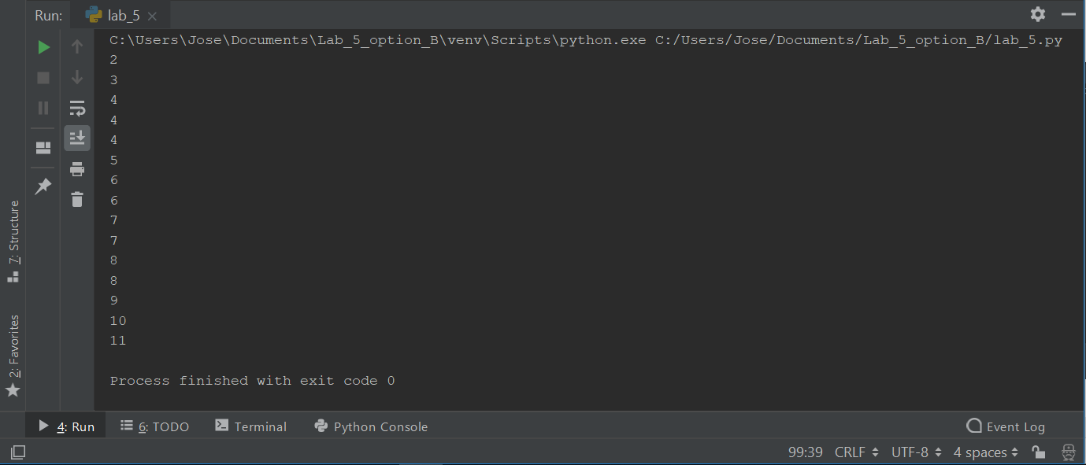

**Testing with file #2**

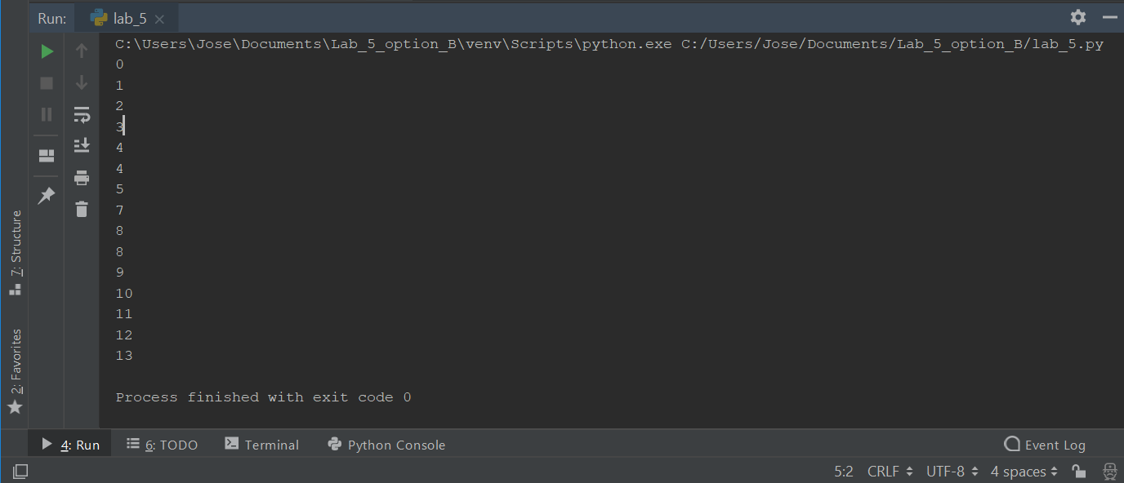

**Conclusion:**

To verify that we created the heap correctly. I created two text files, which I used to test the code. The program will open the file and it splits the numbers when we see a “,” it creates a new node. Once the programs had separated all the numbers from the file. It will populate the Heap, with the root being the smaller number. We have different options to test the lab. In my case I decided to create a new file, that I can just change the name of the file.